2.2 The Derivative as a Function

The following example is based on the Desmos Animation from the 5A page.

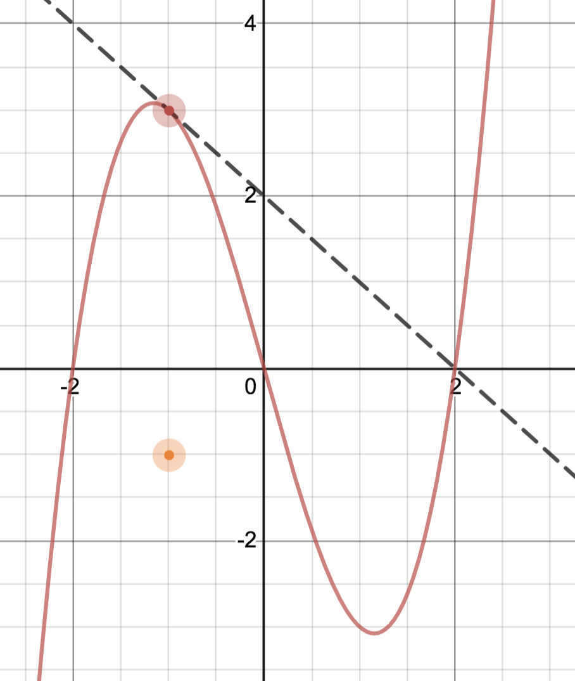Use the graph of f(x) below to estimate 

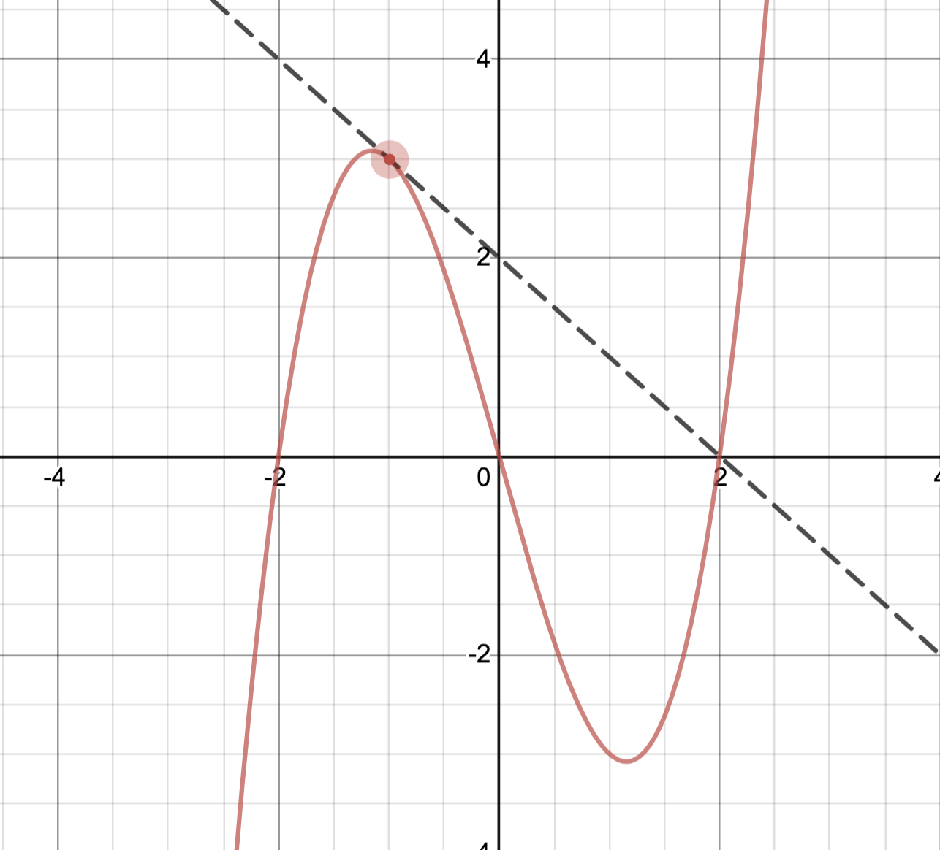

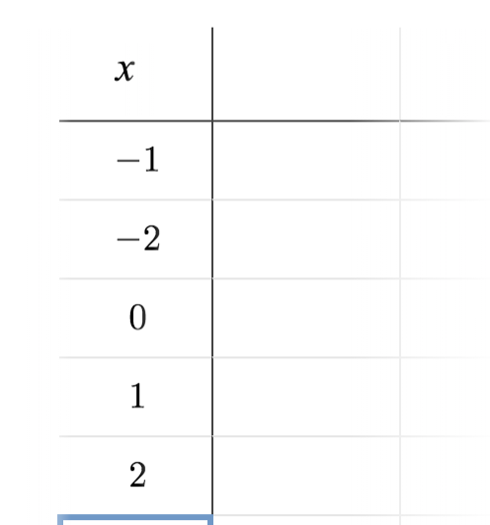

Now draw a point on the graph that as x value of -1 and y value that is  .

Repeat the above steps for x=-2,-0,1,2

We have created a new function 

The ________________ value on the graph of  corresponds to the _____________________of the graph of .

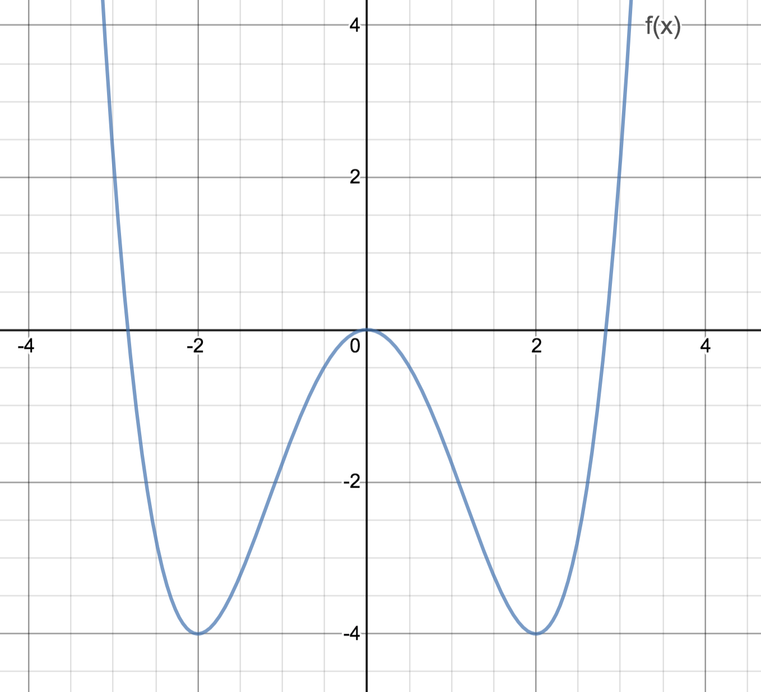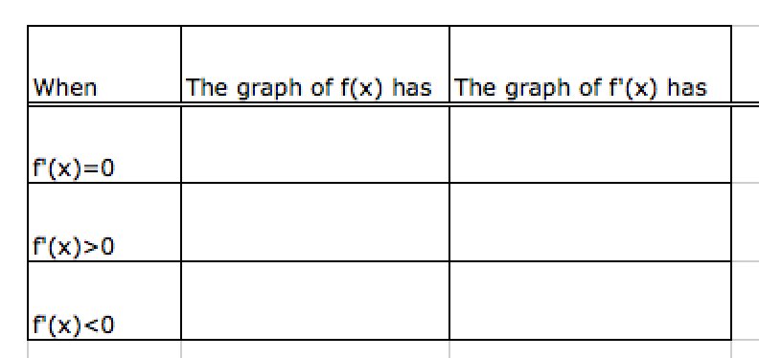

Given the graph of ,sketch the graph of .

Example (1) : Given the graph of ,sketch the graph of .

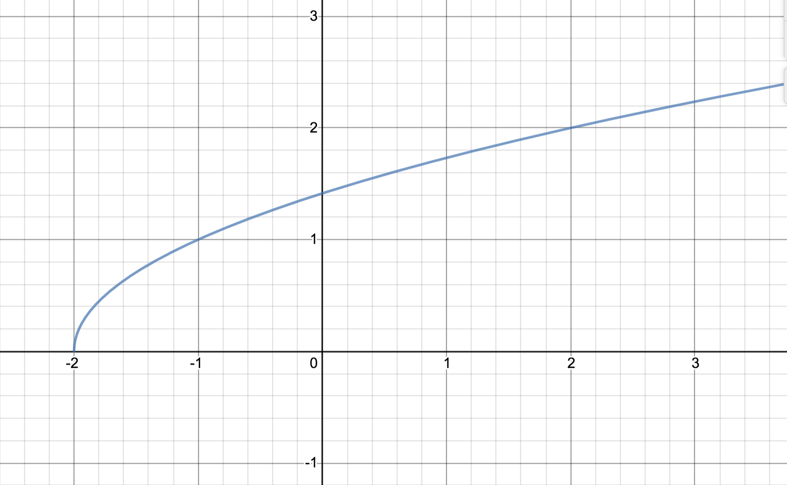

Now compute . Look at the estimated graph vs. the algebraic computation.

Substituting x for a in  we get =

What is the domain of ? __________________ What happens at x=-2?______________

Generalizing definitions:

Derivative at a specific point: General derivative function:

 

 

*PROVIDED THE LIMIT EXISTS*

If the limit does not exist for x=a, we say  is not differentiable at x=a.

In the above example,  fails to be ___________________________ at x=-2.  IS

differentiable on the interval _________________________

Alternate notation for 

If  then we write , or if

, we would write 

Think of  as a _______________________ and  as a ________________________________

So we would not write  nor 

Example 2: , find  (or find __________________ )

Example 3: , find 

Examples 1, 2, and 3 show the three ways in which a function fails to be differentiable at a given point:

1)________________________________

2)________________________________

3)________________________________

Algebraically, to determine where f is differentiable, we find the domain of 

Theorem: IF  is differentiable at x=a, THEN  is continuous at x=a

( Differentiability at x=a  Continuity at x=a )

Logic Basics:

Conditional Statement:

Converse:

Contrapositive:

Proof:

Given that  is differentiable at x=a, we know 

:

:

:

Higher derivatives

Since  is a function itself, we can take the derivative of it to create a new function which we denote ___________________

Using Leibniz notation,  = __________________________

Likewise, we can take higher order derivatives: __________________________

Application: If s(t) is the position function of an object that moves in a straight line, then

_______________________________

_______________________________

2.3i Differentiation Formulas

We can easily show

   

Theorem: If n is a positive integer then 

Proof: (see book for a different approach):

=

We will learn later that this rule applies for all real exponents n.

Examples:

  

Important notation:

 is an operator. It is telling us to take the derivative It always has an argument. 

 is the name of the derivative.

So if  we can say  or  or  or 

But it is INCORRECT to say  or 

Also, arguments should match: , 

The Constant Multiple Rule: If c is a constant and f(x) is a differentiable function then 

Example:

Proof:

The Sum and Difference Rule: If f(x) and g(x) are differentiable then 

Example:

See proof in book.

The Product Rule: If f(x) and g(x) are differentiable then 

Often abbreviated:

Derivation: (differs from book)

=

Example:

The Quotient Rule: If f(x) and g(x) are differentiable then 

Often abbreviated:

Examples: Find :

 

Tip: Many functions are easier to differentiate if you simplify first and write as a power function when possible rather than immediately apply the product or quotient rule.

Examples: Find :

   

2.3ii More challenging tangent problems

Example:

1) Find the equation of the tangent line to  at x=2

2) Find the equation of the tangent line to  that contains the point (2,0)

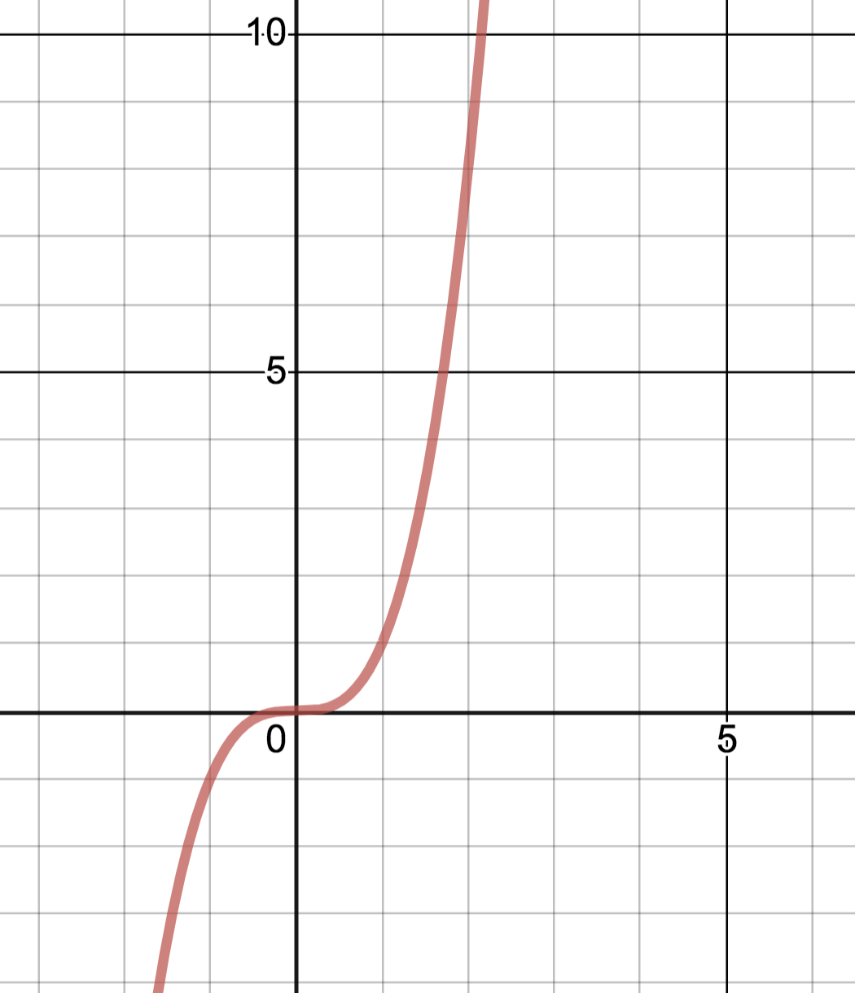

See Example 2.3ii on 5A page:

<https://www.desmos.com/calculator/nc9gc2jdqq>

2.4i Derivation of Derivatives of the Trigonometric Functions and special limits

Find a formula for the derivative of 





 (see below)





(see next page)



Similarly, we can show 

With these formulas, all the other trigonometric derivatives can be easily found:

Find 

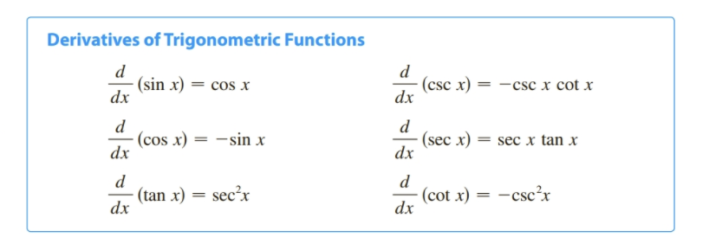

Examples: Find  if  Find  Find  if 

2.4ii Limits

Finding the limit  and 

(Development differs from book)

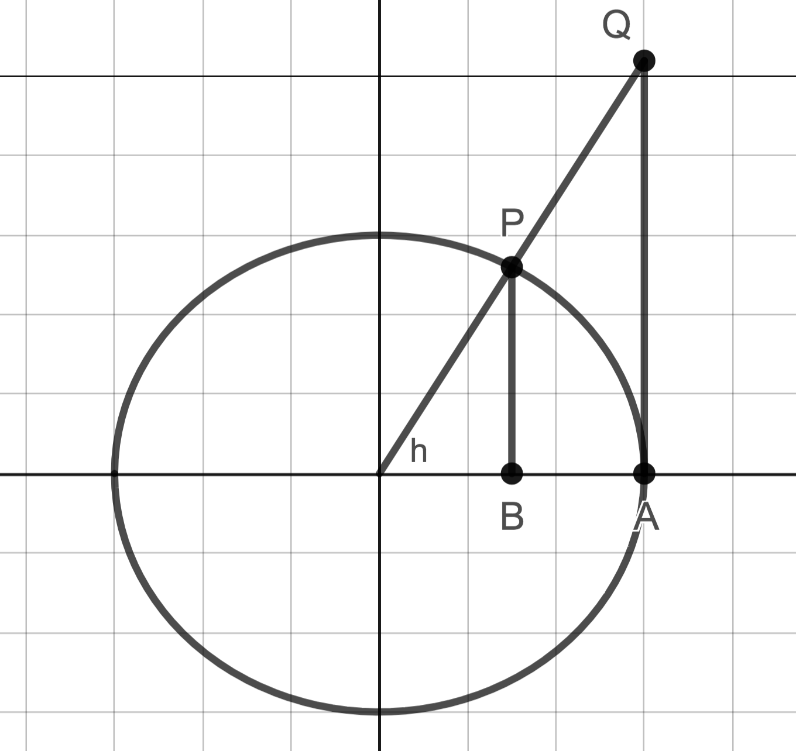

The from here,  =

Examples:  

Note Outlines 2.5 – The Chain Rule

SUPER IMPORTANT TO MASTER THIS SECTION

How would we find the derivative of f(x)=sin(2x)?

Need a way to find the derivative of composite functions

Review of compositions of functions

Ex: If  and , find  and 

Going backwards, decompose the following functions:

  

We will need to be able to recognize when we have a composite function and we will need to identify from the outermost function to the innermost function.

Development of the Chain Rule

Let . We need to find the derivative.

 .

Make a temporary substitution for visual help, let v=g(x) and u=g(a), then

=

Example using the notation precisely:

Given F(x)= sin(2x), find F’(x)

How we do this in practice.

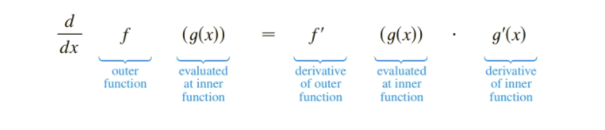

 =

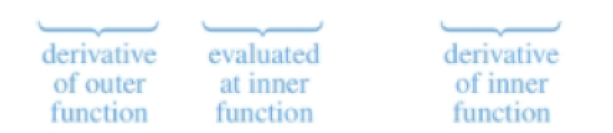

Another way of thinking about it: If the inner function WAS x…….



Example: Find  (2 “layers”, apply chain rule once)

(1)  (2)  (3) 

Example: (3 “layers”, apply chain rule twice) 

Example: (Using chain rule instead of quotient rule): 

Examples: (Combining all the differentiation rules.)

(1) 

(2) 

(3) 

Examples: (Abstract) Find :  

2.6 – Implicit Differentiation

Review notation

= =  = =

Review chain rule on abstract problem:

  

Reconsider  What if y was representing a function of x, ?

Then  = =

Motivating Problem: Find the slope of the tangent line to  at the point (3,-4)

Explicitly

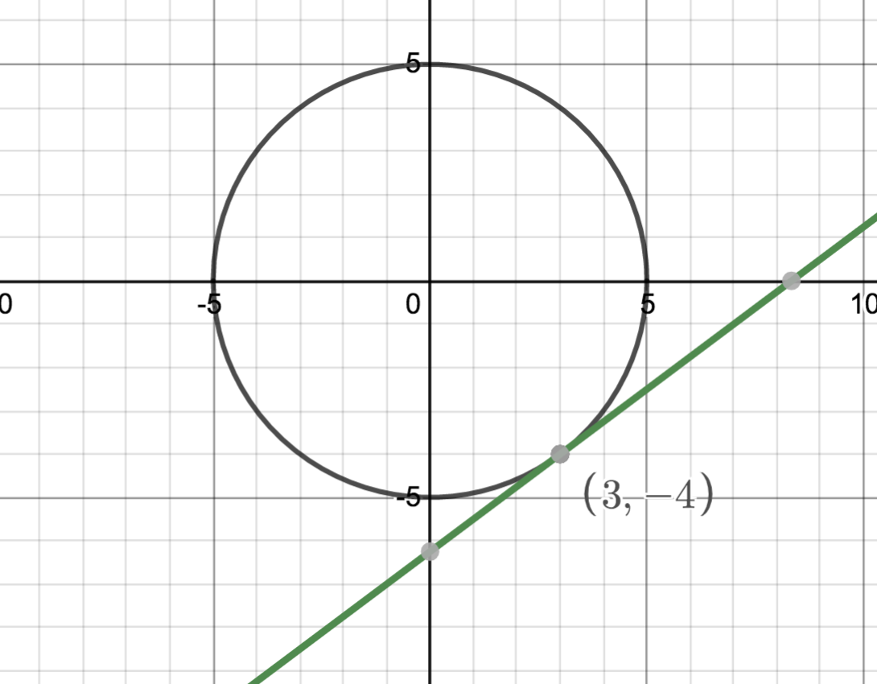

Implicitly: 

Example: Find : 



\

Example: 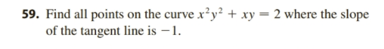

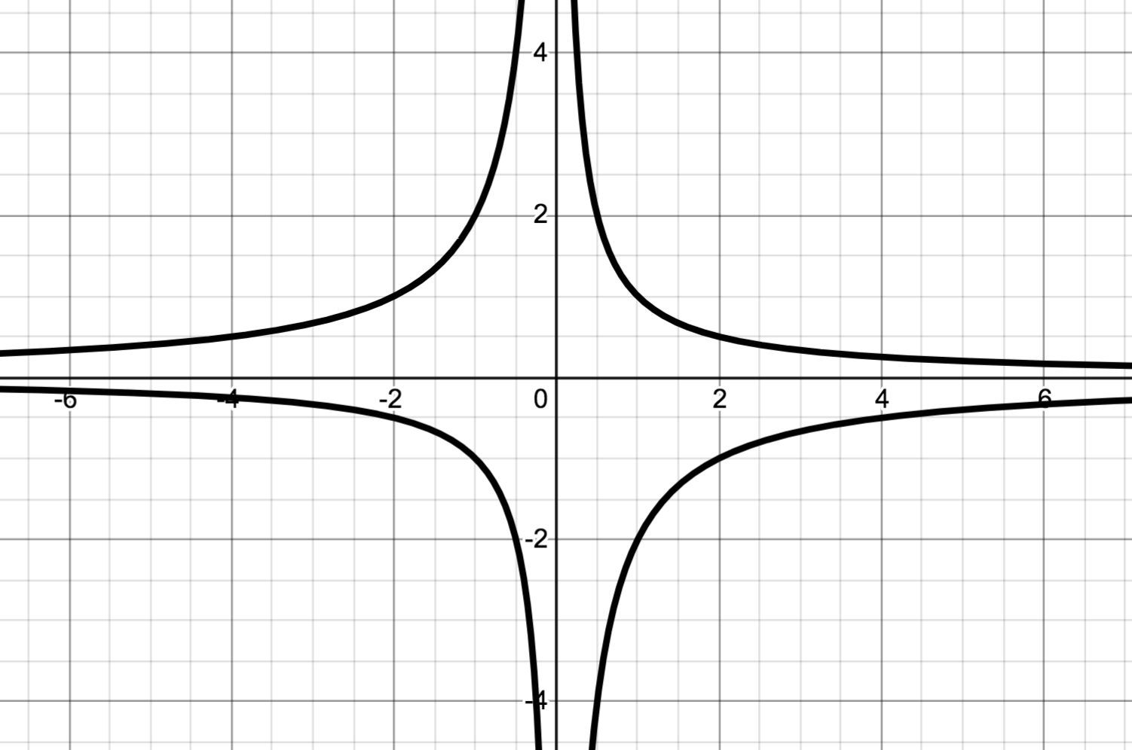

2.8 Related Rates

Consider the following problem. A rocket is rising vertically, and an observer watches at a distance of x feet away. 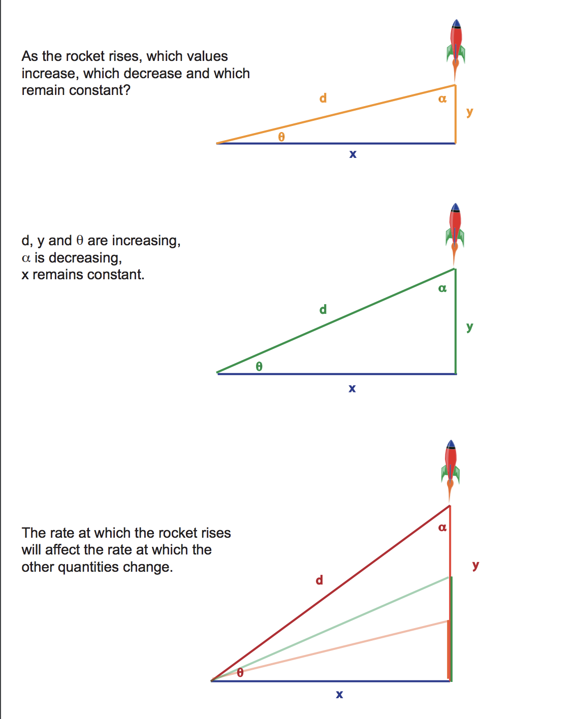

What do each of the following represent, physically?

Are they positive or negative? If distance is measured

In feet and time in seconds, what are the units? 

These rates are all related.

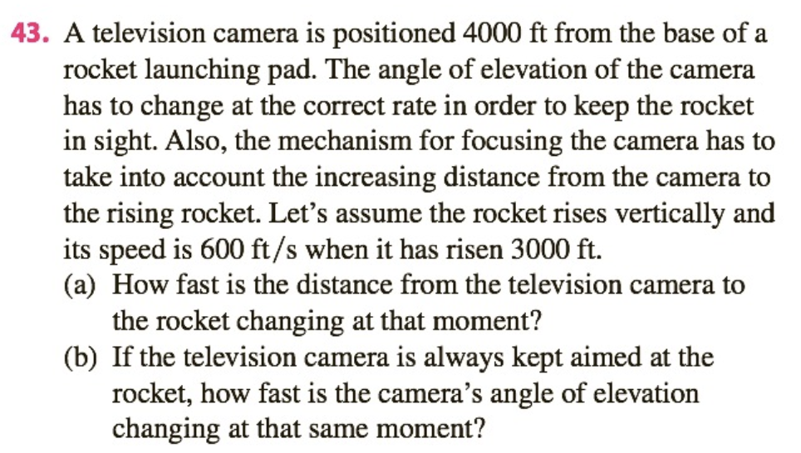

Sketch a picture. Put in any values which are NOT changing. Assign a variable (and label) to any quantities of interest that ARE changing.

(a) What rate do you know? What rate do you WANT to know?

Create an equation relating _________________ and __________________________.

Differentiate both sides with respect to t.

Evaluate at the specified moment of interest. A separate picture for that moment in time might help.

(b)

Example:

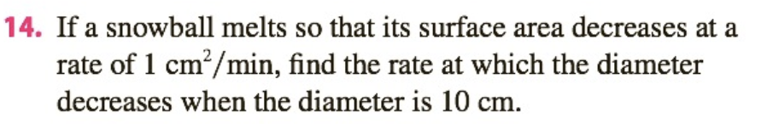

Example: Water is flowing into a conical tank which has height of 16 cm and radius of 4 cm at a rate of 2 cm3/min. How fast is the water level rising when it is 10 cm deep?

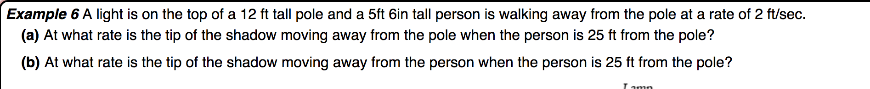

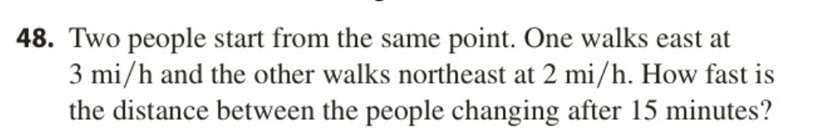

2.9 Linear Approximation and Differentials

Linear Approximation:

Suppose we are given a function and we can easily compute . Further suppose we want to compute the value of  for an x value near , but is complicated to compute for that value of x.

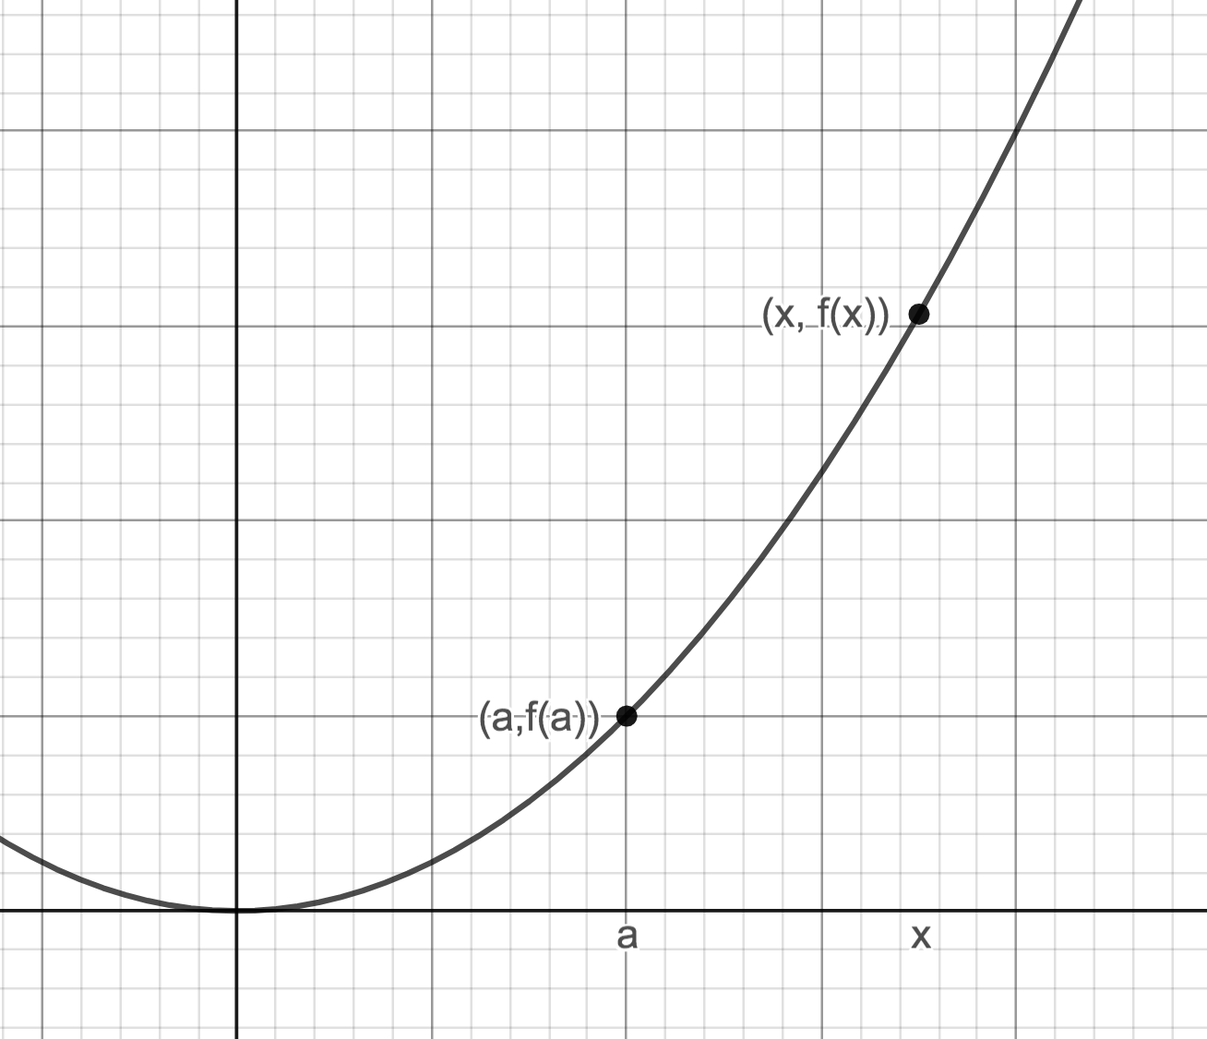

Find the equation of the line tangent to at x=a

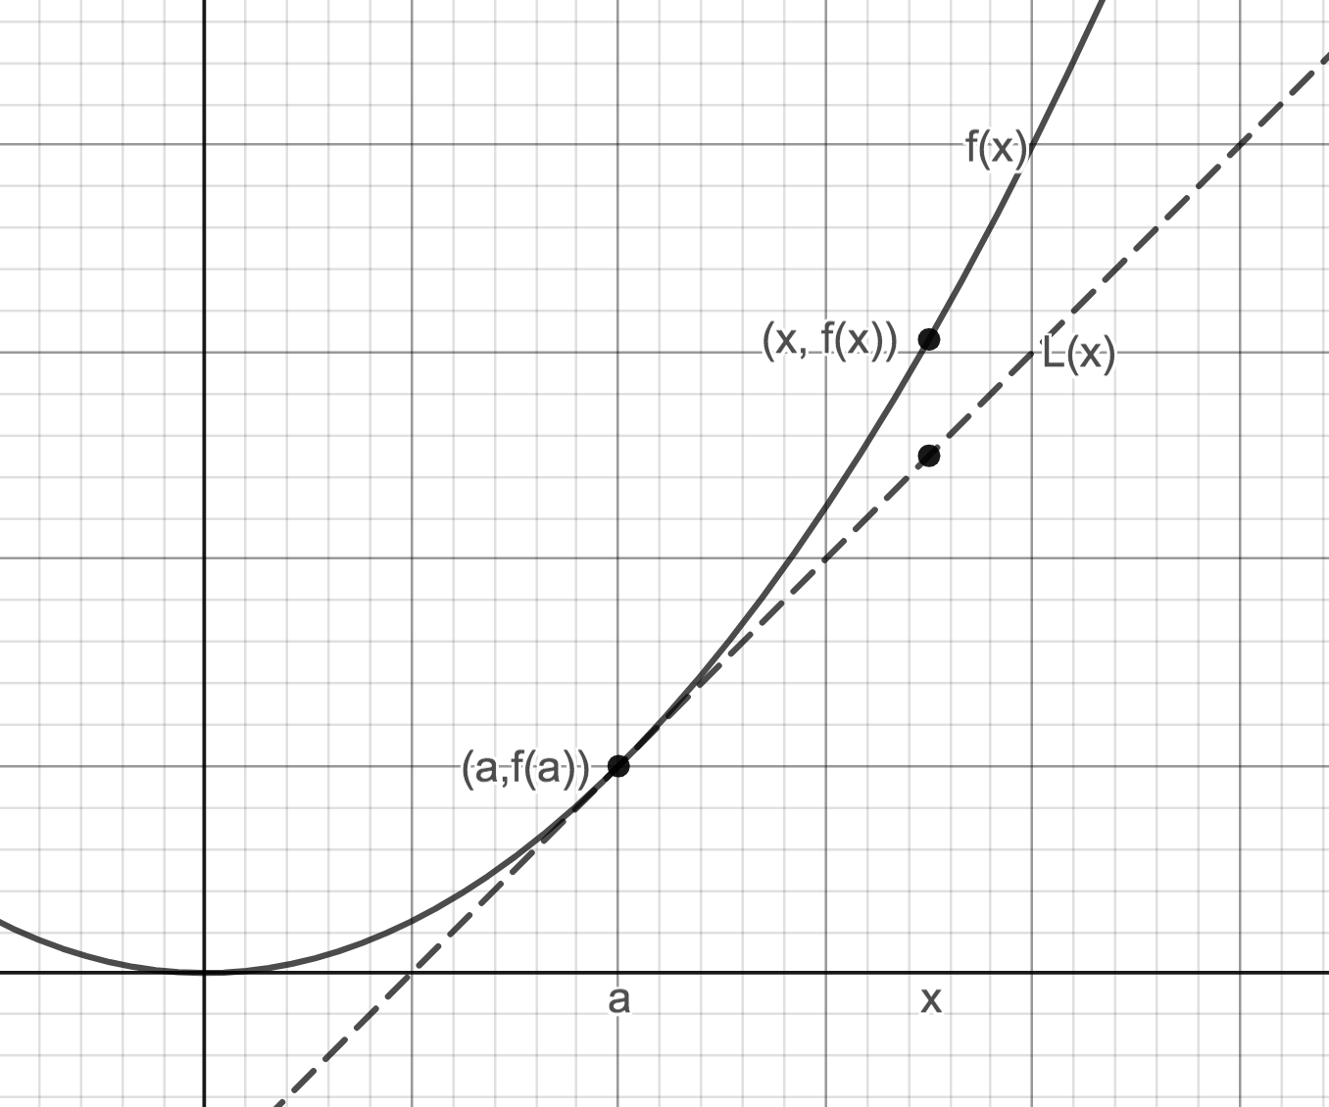

We can compute the value of y for that x value on the tangent line easily, and use it to approximate the y value for that x on f(x) . That is  for x “near a”.

Example: Find a linear approximation for 

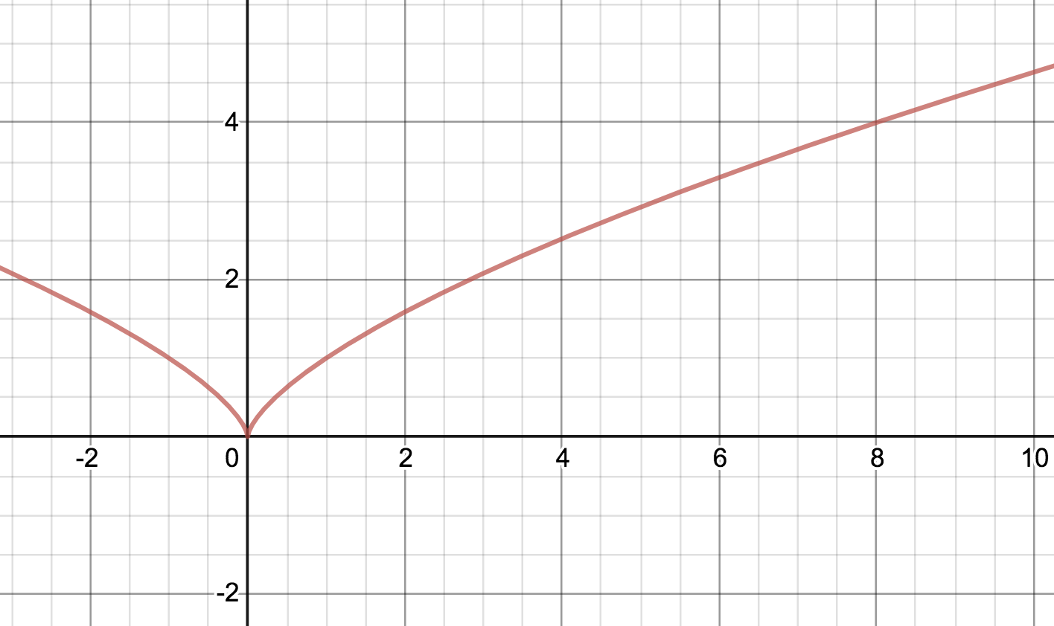

Let ___________________ We want to compute _______________________

Choose . This should be a number near __________________ such that  is easy to compute. =_________________

Find the equation of the line tangent to at x=a.

Find the y value of the point on the tangent line corresponding to x=7.94.

(Calculator Value 3.979974916)

Higher degree polynomial approximations. (See Taylor Series Desmos on 5B page)

Differentials

The derivative,  can also be written as ____________________________

But do dy, dx have any meaning individually?

Definition: The __________________________________, dy, is defined in terms of the differential, dx as:

 (dx is treated as an independent variable)

Example: If  then dy=____________________________ When x=0 and dx=0.2, dy=_________________________________

Graphical explanation of dy.

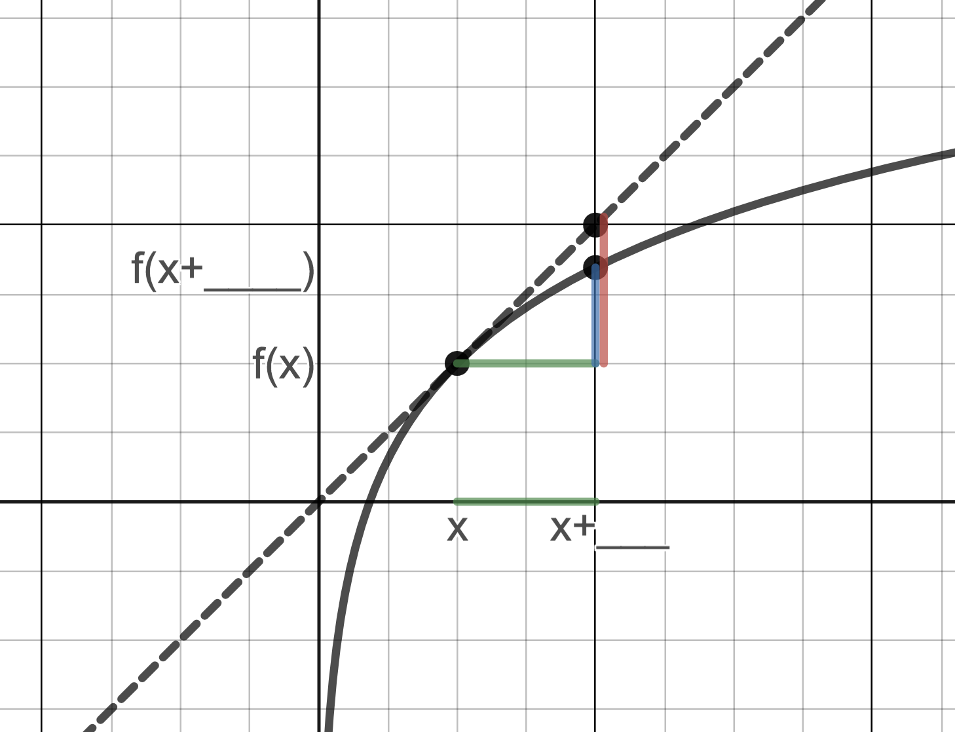

If we let , then for small values of dx, ______________________________________

Differentials are used in two ways;

1)

2)

1) Using differentials to approximate 

Example: Given , compute and compare  and dy for x=1,  Show  and dy on the graph.

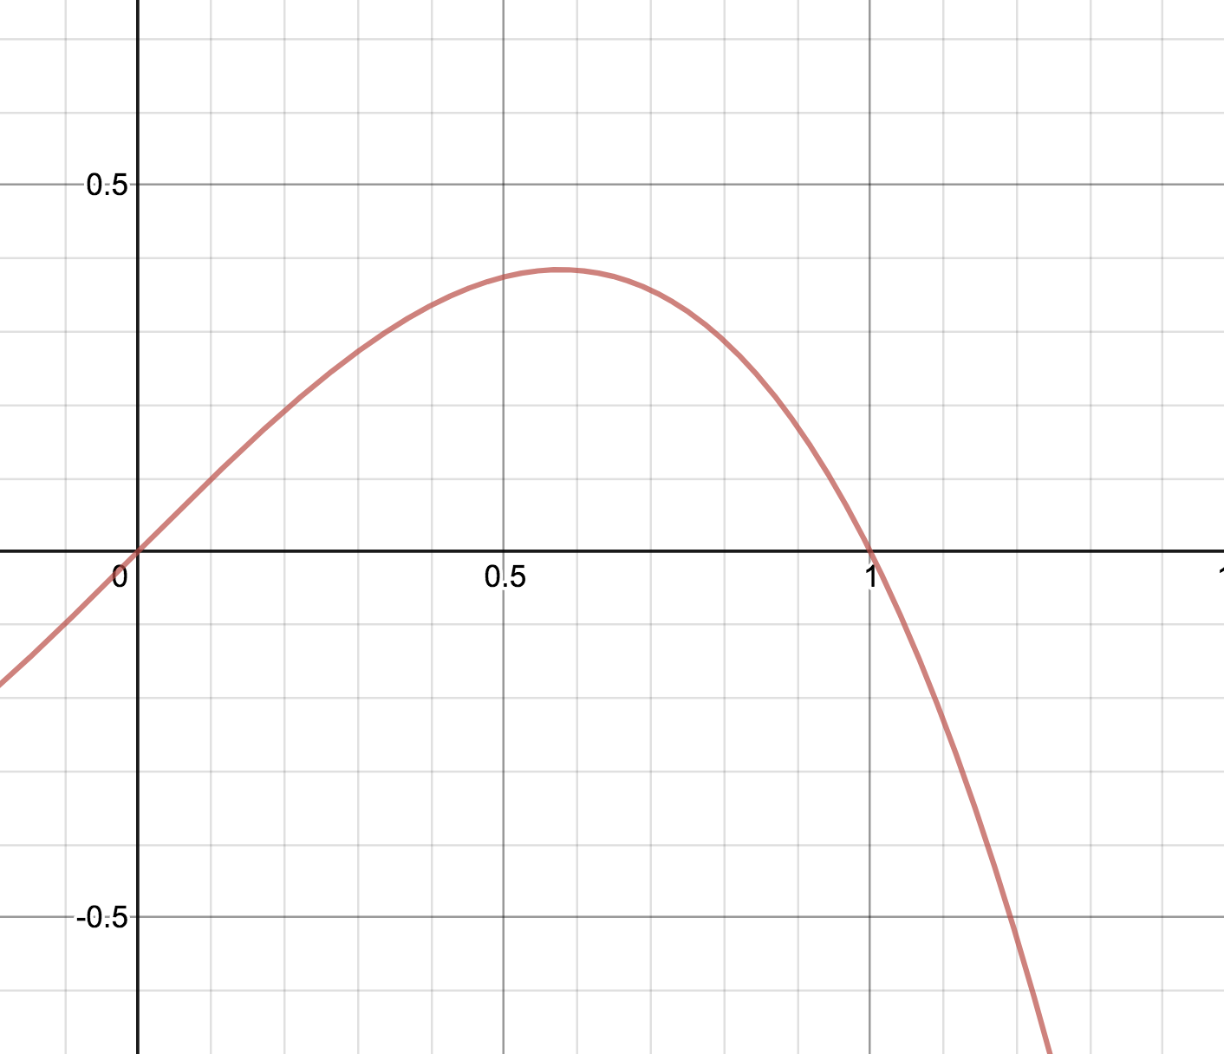

Example:

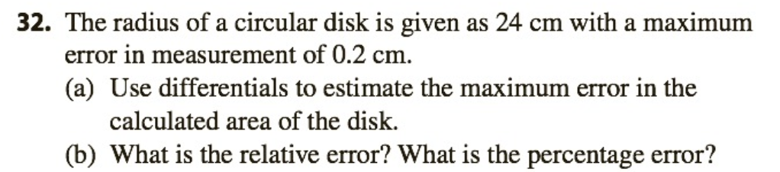

2) Using differentials to approximate  (linear approximation)

Example: Use differentials to find a linear approximation for 

Let ___________________ We want to compute _______________________

Choose x. This should be a number near __________________ such that  is easy to

compute. x=_________________ (x plays the role of “a” when using L(x)). Then

 so 

Example: Use differentials to approximate 